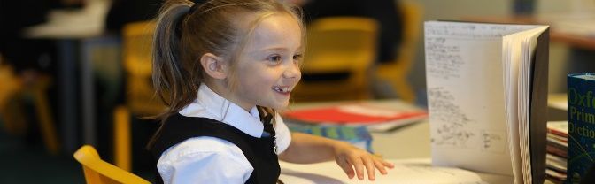
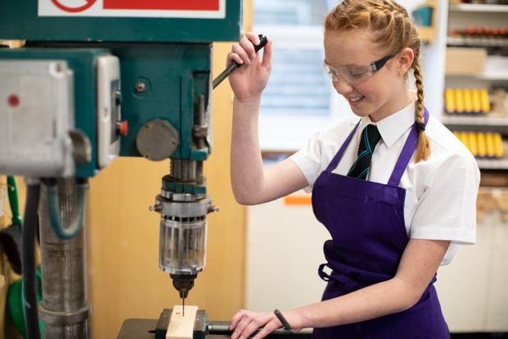

Application Pack and Job Description

Newton Abbot College
Daytime Cleaner

Ivy Education Trust is seeking to appoint a committed individual to join the College’s Premises Team, which is responsible for maintaining the highest standards for our students.

You will undertake a range of routine cleaning tasks, monitoring toilets, checking main entrances and thoroughfares, litter picking and providing a responsive emergency cleaning service throughout the college day.

The Ivy Education Trust works closely with all schools within the Trust and beyond. The Ivy Education Trust celebrates the diversity of each of its schools and is founded upon the alignment of vision and values that we all commonly hold to secure the best outcomes for our pupils.

The name of our Trust is inspired by the story of Dr Ivy Williams. Born in Teignbridge (Newton Abbot), in 1877, she managed what we would wish for all the children and young people of Teignbridge and surrounding area that we serve in our schools by fulfilling her childhood dreams and ambitions.

On 10 May 1922 Dr Ivy Williams became the first woman to be called to the Bar (formally recognised as a qualified Barrister of Law) of England and Wales.

The story of Dr Ivy Williams reminds us of the famous quote from Michelangelo:

“The greater danger for most of us lies not in setting our aim too high and falling short; but in setting our aim too low, and achieving our mark.”

The Ivy Education Trust supports and challenges all members of our learning community to dream big, aim high, and achieve more than they ever thought was possible.

If you share these visions and aspirations, then we very much welcome your application for this post.

Application forms and further information are available from our website, www.ivyeducationtrust.co.uk or via email to people@ivyeducationtrust.co.uk

Closing date for applications is Friday 23rd September 2022 @ 09:00. Interviews will take place week commencing 26th September 2022.

Job Description

Job Title: | Daytime Cleaner
Location: | Newton Abbot College
Responsible to: | Senior Maintenance Technician
Salary:  Working Hours: | Scale 1-2, Point 1-3 Starting salary £18,333 (full time equivalent p.a pro rata) Actual salary £16,505.  37 hours a week, 41 weeks a year (08:30 – 17:00 Monday to Thursday; 08:30 – 16:30 Fridays – with 1 hour unpaid lunch break)
Contract:  Start Date: | Permanent  Immediate start
Key Purpose of Job:
- To provide an efficient, effective, and responsive cleaning service throughout the College

Main Duties:
Individually or as part of a team, maintain high standards of cleanliness across the College throughout the College day by taking a proactive approach to:

- Site monitoring and cleaning to include:
  - Toilet areas
  - Replenishing consumable items (soap, toilet rolls, paper towels) when required
  - Spot cleaning of spillages
  - Vacuuming, sweeping, moping when required
  - Leaf clearance of subway and footpaths
  - Supporting the Premises Team with applying de-icing salt when required
  - Timely removal of graffiti where found or reported
- Checking entrances and main thoroughfares and removing litter to designated collection points
- Using cleaning products as directed and trained
- Using electrically powered machines as required and trained
- Contribute to cleaning tasks during College holiday periods
- Responding to emergency calls to provide a rapid response cleaning service
- Undertaking regular litter picking patrols throughout the day to ensure the College is litter free
- To undertake Portering duties, including the distribution of post/parcels across the College
- Undertake daily cleaning duties of a dedicated area
- Ensure bins are empty prior to the beginning of College holiday periods

Responsibilities
- Being proactive in reporting items requiring repair or replacement to Senior Maintenance Technician
- Identifying and reporting health and safety matters to the Senior Maintenance Technician
- Undertake minor maintenance work, eg replacing toilet roll and soap dispensers under the direction of the Cleaning Supervisor and Senior Maintenance Technician
- Maintaining effective communication with both staff and students at all times
- Adhering to working practices, methods and procedures, undertaking relevant training and development activities and responding positively to new and alternative systems
- Maintain stock levels of cleaning materials, requesting replenishment from the Cleaning Supervisor when required
- To ensure the security of cleaning stores and materials at all times
- To follow the colour coding for cleaning to eliminate cross contamination of areas
- Carrying out any other reasonable duties and responsibilities within the overall function, commensurate with the grading and level of responsibilities of the post
Other duties
- To follow the College’s ICT policy for the safe use of ICT
- To be aware of and assume the appropriate level of responsibility for safeguarding and promoting the welfare of children and to report any concerns in accordance with the College’s safeguarding policies
- To comply with legislation, policies and procedures relating to confidentiality and data protection, reporting any concerns to the appropriate person.
- To work in compliance with the Codes of Conduct, Regulations and policies of the College and its commitment to equal opportunities
- To comply with the College’s Health & Safety policy and statutory requirements as detailed in the Health & Safety at Work manual
- Recognise own strengths and areas of expertise and use these to advise and support others and undertake any training and personal development as and when identified by your Line Manager
- To undertake any other duties as deemed appropriate by the Headteacher
- Contribute to the overall ethos/work/aims of the College
- Attend and participate in meetings as directed

Uniform and equipment will be provided.

This is not an exhaustive list of duties; they may be varied from time to time without changing the general character of the job or the level of responsibility. A high degree of flexibility and adaptability is an important element of this role.
This is a description of the role as it is now. We periodically examine employees' job descriptions and update them to ensure that they reflect the job as it is then being performed, or to incorporate any changes being proposed. We aim to reach agreement on reasonable changes, but if agreement is not possible, we reserve the right to insist on changes to your job description after consultation with you.

Person Specification

Criteria | Essential | Desirable
Qualifications

Basic level of literacy and numeracy
Willingness to participate in training/ development as/when identified by line manager
Professional Experience and Knowledge
Proven experience of commercial cleaning
Ability to use cleaning machinery, eg, buffing machine
Manual handling
Personal Aptitudes, Qualities and Skills

Highly motivated and enthusiastic
High professional standards
Knowledge of basic Health and Safety
Good communication skills to enable positive interaction with students, staff and visitors
Able to work safely and effectively on own initiative
Flexible approach
Attentive to detail
A commitment to working to strict deadlines
Evidence of continuing professional development

Ability to work effectively as a member of a team
Understanding of safeguarding issues and promoting the welfare of children and young people
Suitability to work with children

