MFL TRIPS

We pride ourselves on running fantastic trips here at Dawlish College in order to experience the wonderful cultural aspects of language learning. Students have the opportunity to go on trips to Normandy, Paris, Barcelona and Madrid. Here are some tasters of past trips we have run.
Normandy
At KS3 we run a trip to Normandy. Students have the opportunity to practise their French and immerse themselves in the local culture as well as the chance to learn and understand about the Second World War, and the sacrifices which were made by those who fought. The trip gives a fantastic insight into European history, with a visit to the D Day Landings Museum, Bayeux Tapestry, British and German war cemeteries, Juno Beach centre and Arromanches 360° Cinema. There is also fun to be had with quizzes and talent shows to fill the evenings, as well as a visit to La Saffrie goat farm, where students can feed, milk and groom the goat.
Student comments:
‘Normandy is an amazing, historical place… on the trip many people grew closer together and came home with new friends!’ – Molly Tripe
‘You will really enjoy this trip because it will change your view of life and make you realise how lucky you are to live away from war.’ – Lily Clarke
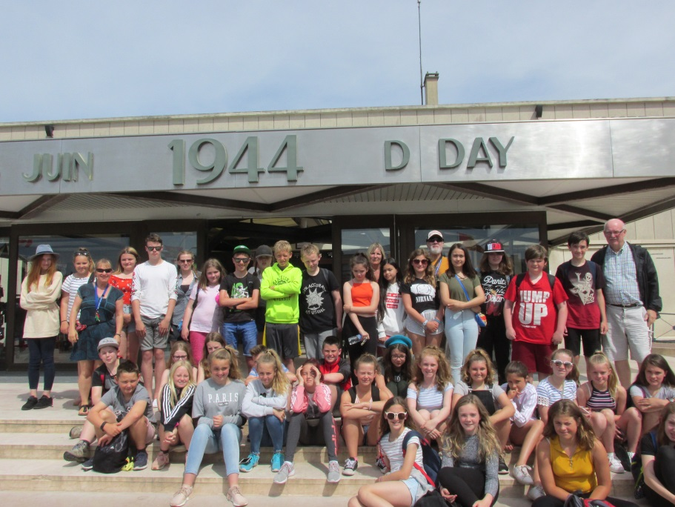

Paris
Students studying French in years 9, 10, and 11 have the opportunity to visit Paris. They experience the cultural and linguistic aspects of the city as well as all the magic that Paris has to offer. During this fun-packed trip they visit Art Galleries such as the Louvre and Pomdipou, take a boat trip along the famous river Seine, explore a typical Parisian market, spend time in a French school meeting and chatting to French students, visit the Arc de Triomphe and also go up to the top of the Eiffel Tower. They eat out on the Champs Elysées at night and have the chance to soak up Parisian nightlife. In the evening, they can let their hair down at a disco in the hostel and there is a bowling evening on the last night.
‘We had hours of shopping and souvenir collecting wherever we went, giving everyone a chance to use their French vocabulary and phrases. Many thanks go to the staff who organised the trip and made a tremendous effort in keeping everyone happy and eager to take part in whatever we were doing. This is definitely a trip I would recommend.’
– Chesten Worden

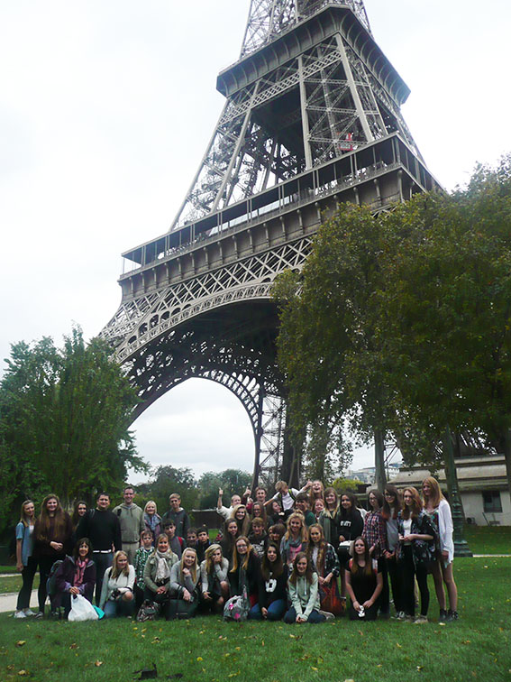

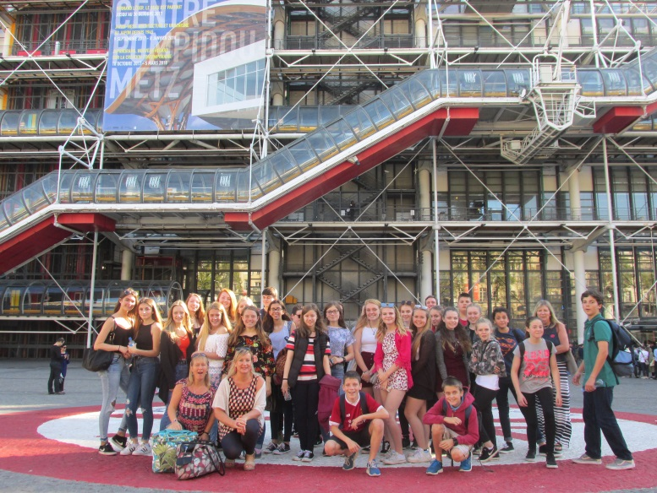

Madrid
A 5-day visit to the Spanish capital is the perfect opportunity for students in years 9, 10 and 11 to experience the country they have been studying first-hand. Students visit the Royal Palace and the Valle de Los Caidos as well as having fun visiting a theme park, eating Tapas and shopping in the markets where students are encouraged use their Spanish to barter. The Bernabeu football stadium is also a big hit!
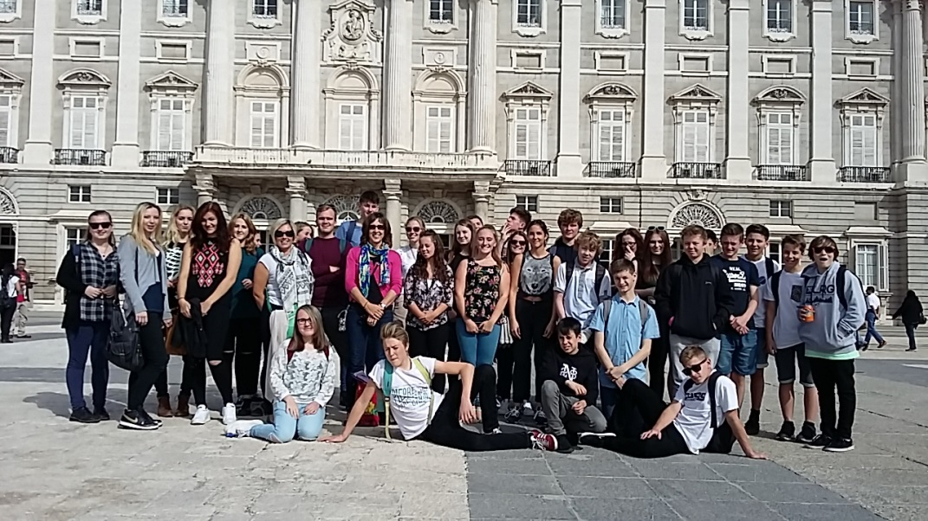

Barcelona

If not Madrid then Vive Barcelona! This is a varied trip that ranges from historic walks through the Gothic Quarter and the Boqueria market, to exploring the cultural and religious landmarks of the city such as Gaudi’s Parc Guell and the stunning Sagrada Familia Basilica, before soaking up the cultural delights of the Picasso Museum and the Columbus Column, then experiencing the awe of Nou Camp stadium before the thrills of an afternoon at Tibidabo theme park. We even find time to hit the beach and do some shopping.

